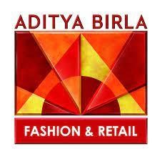

# Aditya Birla Fashion and Retail Limited

Aditya Birla Fashion and Retail Limited (ABFRL) is an Indian fashion retail company headquartered in [Mumbai.](https://en.wikipedia.org/wiki/Mumbai) ABFRL has a network of 3031+ stores with a presence across 25,000 multi-brand outlets(approx.) with 6,500+ points of sales in department stores across India.

Madura Garments was established in 1988, acquired by the Aditya Birla Group in 1999, and was re-christened Madura Fashion & Lifestyle in 2010. MFL brands include [Louis Philippe,](https://en.wikipedia.org/wiki/Louis_Philippe_(brand)) Allen Solly, and Peter England. The Collective, India's first and largest multi-retail brand for international brands, was launched in 2008. In 2016, ABFRL struck a deal with a global luxury brand [Ted Baker](https://en.wikipedia.org/wiki/Ted_Baker) and also signed an MOU With [Forever 21](https://en.wikipedia.org/wiki/Forever_21) for India Business. In 2013, [Aditya Birla Nuvo Limited (ABNL)](https://en.wikipedia.org/wiki/Aditya_Birla_Group) (ABNL) took over Pantaloons.[[6]](https://en.wikipedia.org/wiki/Aditya_Birla_Fashion_and_Retail#cite_note-6) In May 2015, ABFRL came into form after the consolidation of the apparel businesses of the Aditya Birla Group, consisting of ABNL's Madura Fashion division and ABNL's subsidiaries- Pantaloons Fashion and Retail Ltd (PFRL acquired in

2013) and Madura Fashion & Lifestyle (MFL established in 1988) in May 2015. Post the consolidation, PFRL was renamed Aditya Birla Fashion and Retail Ltd. In 2017, ABFRL brought [Simon Carter](https://en.wikipedia.org/wiki/Simon_Carter) to India.[[9]](https://en.wikipedia.org/wiki/Aditya_Birla_Fashion_and_Retail#cite_note-9) In the same year, ABFRL entered into a strategic alliance with [American Eagle.](https://en.wikipedia.org/wiki/American_Eagle_Outfitters) In 2018, ABFRL entered into a Store License and Distribution Agreement with Ralph Lauren Asia Pacific Limited (“RLAPL”), which offers apparel and accessories for both men and women under the brand name "Polo Ralph Lauren" and [Ralph Lauren.](https://en.wikipedia.org/wiki/Ralph_Lauren_Corporation) n 2019, ABFRL acquired ethnic wear brands, Jaypore and TG Apparel & Décor, for an enterprise value of up to

₹110 Crore.[[12](https://en.wikipedia.org/wiki/Aditya_Birla_Fashion_and_Retail#cite_note-12)[][13]](https://en.wikipedia.org/wiki/Aditya_Birla_Fashion_and_Retail#cite_note-13) In the same year, the company bought a 51% stake in M/s Finesse International Design Private Limited (“Finesse”) under the brand name Shantanu & Nikhil.[[14]](https://en.wikipedia.org/wiki/Aditya_Birla_Fashion_and_Retail#cite_note-14)

In 2019, ABFRL launched a chain of large format value fashion stores, named Style Up. Style Up typically operates large format stores, sized between 6,000 and 8,000 sq. ft, selling ethnic and western apparel and accessories for men, women, and children.[[15]](https://en.wikipedia.org/wiki/Aditya_Birla_Fashion_and_Retail#cite_note-15)

In 2021, ABFRL announced a strategic partnership with India's largest design brand ['Sabyasachi'](https://en.wikipedia.org/wiki/Sabyasachi_Mukherjee) by signing a definitive agreement for acquiring a 51% stake in 'The Sabyasachi brand. This partnership will add significant weight to ABFRL's growing ethnic wear portfolio, and the platform will complement the brand on its journey to becoming a global luxury house out of

India. [[16]](https://en.wikipedia.org/wiki/Aditya_Birla_Fashion_and_Retail#cite_note-16) [[17]](https://en.wikipedia.org/wiki/Aditya_Birla_Fashion_and_Retail#cite_note-17)

In 2021, ABFRL acquired a 34% stake in [Tarun Tahiliani's](https://en.wikipedia.org/wiki/Tarun_Tahiliani) luxury business with an option to increase this shareholding to 51 percent in the next few years. ABFRL also entered into a partnership with Tahiliani to form a new entity that will develop and launch affordable premium ethnic wear and accessories. ABFRL will hold an 80 percent stake in this new brand.[[18](https://en.wikipedia.org/wiki/Aditya_Birla_Fashion_and_Retail#cite_note-18)[][19]](https://en.wikipedia.org/wiki/Aditya_Birla_Fashion_and_Retail#cite_note-19)

In June 2021, Jaypore, part of Aditya Birla Fashion and Retail Limited, entered into the menswear

category.[[20](https://en.wikipedia.org/wiki/Aditya_Birla_Fashion_and_Retail#cite_note-20)[][21]](https://en.wikipedia.org/wiki/Aditya_Birla_Fashion_and_Retail#cite_note-21)

In January 2022, ABFRL acquired a 51% stake in [Masaba Gupta's](https://en.wikipedia.org/wiki/Masaba_Gupta) brand House of Masaba Lifestyle for Indian rupees 90 crores.

**PROMOTING BODY**

|  |  |  |
| --- | --- | --- |
| Name | Designation | |
| Arun Adhikari | Independent Director | |
| Ashish Dikshit | Managing Director | |
| Chandrashekhar Chavan | Chief Human Resource Officer | |
| Geetika Anand | Co. Secretary & Compl. Officer | |
| Himanshu Kapania | Vice Chairman & Non Exe.Dire | |
| Jagdish Bajaj | Chief Financial Officer | |
| Kumar Mangalam Birla | Chairman & Non-Exe.Director | |
| Naresh Tyagi | Chief Sustainability Officer | |
| Nish Bhutani | Independent Director | |
| Praveen Shrikhande | Chief Digital Officer | |
| Preeti Vyas | Independent Director | |
| Puneet Malik | CEO - innerwear Business | |
| R Satyajit | Chief Executive Officer | |
| Sangeeta Pendurkar | Whole Time Director | |
| Sukanya Kripalu | Independent Director | |
| Sunirmal Talukdar | Independent Director | |
| Swaminathan Ramachandran | Chief Supply Chain Officer | |
| Vikram Rao | Independent Director | |
| Vishak Kumar | Whole Time Director | |
| Yogesh Chaudhary | Independent Director | |
|  |  |  |

# AREA OF OPERATION

Aditya Birla Fashion and Retail Ltd. (ABFRL) emerged after the consolidation of the branded apparel businesses of [Aditya Birla Group](https://www.adityabirla.com/) comprising ABNL's Madura Fashion division and ABNL's subsidiaries Pantaloons Fashion and Retail (PFRL) and Madura Fashion & Lifestyle (MFL) in May 2015. Post the consolidation, PFRL was renamed Aditya Birla Fashion and Retail Ltd.

Aditya Birla Fashion and Retail Deals in :

Lifestyle brands - Aditya Birla Fashion and Retail Ltd. (ABFRL) emerged after the consolidation of the branded apparel businesses of [Aditya Birla Group](https://www.adityabirla.com/) comprising

ABNL's Madura Fashion division and ABNL's subsidiaries Pantaloons Fashion and Retail (PFRL) and Madura Fashion & Lifestyle (MFL) in May 2015. Post the consolidation, PFRL was renamed Aditya Birla Fashion and Retail Ltd.

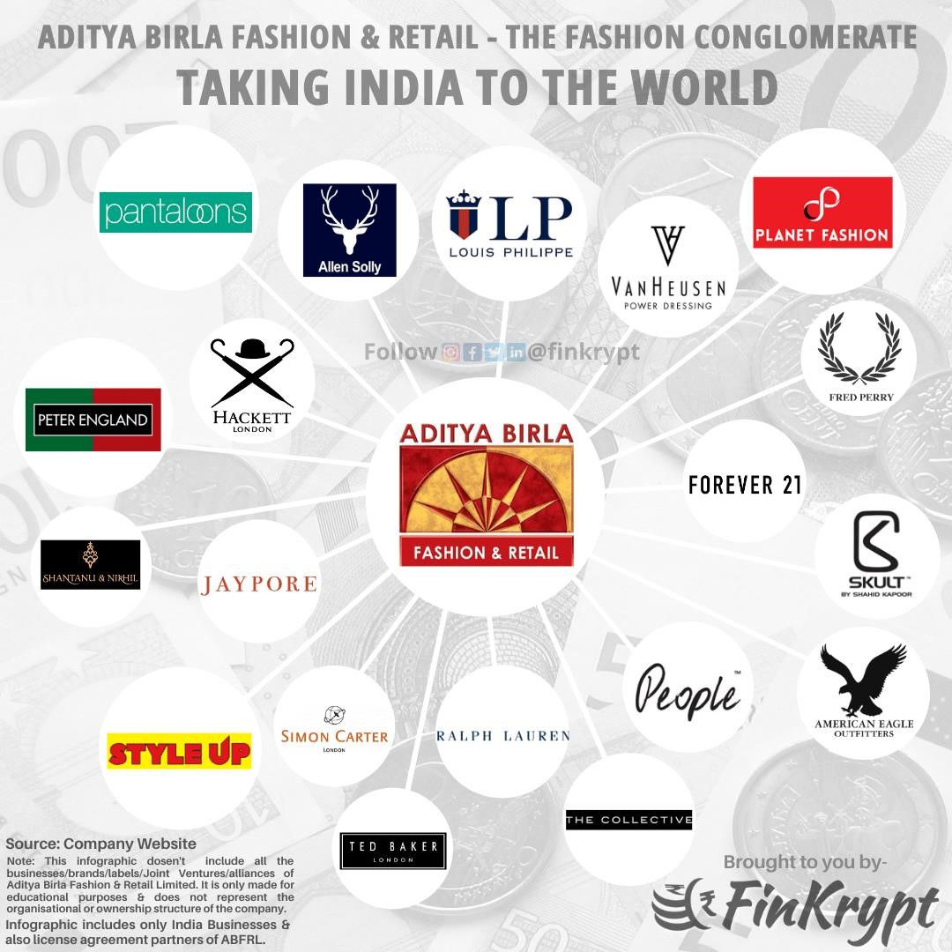

ALLEN SOLLY has been revolutionizing workwear expressions for the last 25+ years and has established itself as the go-to brand for unconventional and versatile fashion. Allen Solly has redefined the rules of corporate dressing - ditching blacks, greys, and whites, the brand adds a pop and flair to dress young men and women in fashionable yet unconventional for work and beyond. In 2021, Allen Solly launched "Tribe", targeting young adults, offering an exciting ensemble of swanky t-shirts, sweatshirts, joggers, jeggings, and much more, curated to allow young consumers to express individuality and chic fashion. The "Tuxedo Wedding" Campaign this year announced Allen Solly's foray into Suits, Blazers, and Tuxedos primarily designed for Occasion wear. The Collection adds a much-needed sense of vibrancy andcolorr to the product offering and aims to redefine occasion dressing for men in India.

UIS PHILIPPE

LOUIS PHILIPPE

When fine craftsmanship meets the mark of excellence, a Louis Philippe product is born. Louis Philippe rises to the occasion of adorning men with impeccable taste and with a refined sense of luxury fashion. For more than 30 years, we've been honoring every moment of a man's life with the grandeur it deserves. From weddings, and business meetings to wardrobe essentials such as blazers and chinos, there's something for everyone. Welcome to the world of Louis Philippe - a statement woven in perfection, stitched together by passion, and styled to perfection.

TER ENGLAND

PETER ENGLAND

Peter England redefines style, attitude, and comfort through its unparalleled range of shirts, trousers, denim, suits and blazers, and t-shirts. It is a brand that has transformed the fashion landscape of today's young Indian men. Adding on to the Brand's wide footprint of 1000+ stores spanning the length and breadth of the country, over 187 new stores were opened in FY21.

To bring positivity in the challenging times, the brand associated with the leading fashion icon Ayushmann Khurrana, as the brand ambassador.

Also, Peter England quickly evolved to the needs of its consumers and introduced new categories such as Antiviral Masks, Antiviral Apparel, and sanitizers and introduced new services such as hyperlocal service. With this, the brand continues to be one of India's leading fashion brands, pioneering innovation, and unmatched quality.

SIMON CARTER

A quintessentially British brand, Simon Carter's uniqueness is embossed in its quirky, yet sophisticated and stylish designs, straddling a full range of men's clothing and accessories.

Launched in London in 1985 and brought to India by ABFRL in 2017, the brand celebrates the spirit of eccentricity and curiosity. The Simon Carter menswear collection is a playful mix of prints and colors, with designs inspired by Simon's adventures with his pet dog Gervaise. With the Royal Family among its admirers, an awkward-winning retail identity and exuberant merchandise, the brand's exciting journey in India has just begun. ON CARTER

SIMON CARTER

A quintessentially British brand, Simon Carter's uniqueness is embossed in its quirky, yet sophisticated and stylish designs, straddling a full range of men's clothing and accessories.

Launched in London in 1985 and brought to India by ABFRL in 2017, the brand celebrates the spirit of eccentricity and curiosity. The Simon Carter menswear collection is a playful mix of prints and colors, with designs inspired by Simon's adventures with his pet dog Gervaise. With the Royal Family among its admirers, an award-winning retail identity and exuberant merchandise, the brand's exciting journey in India has just begun.

PANTALOONS

Pantaloons, a division of Aditya Birla Fashion and Retail Ltd. is a preferred fast fashion destination with over 370+ stores spread across 180+ cities & towns in the country. With its new retail identity, store design, and a wide range of trendy merchandise, Pantaloons has become the playground for its customers to come and explore fashion.

As a brand, Pantaloons is vibrant, expressive, spontaneous, and fun-loving. The brand speaks to the fashion aspirant millennials who are trend seekers and are on the lookout to be at their fashionable best. Pantaloons believes in delivering an experience that is exciting, friendly, and uplifting for its customers and helps them look and feel great!

YOUTH FASHION

Youth Fashion brings fresh take on fashion for Young India. FOREVER 21

Forever 21 in India offers clothes and accessories for Millennials and Gen Z girls and boys, and all those who feel millennial-age at heart. Forever 21 began its journey in 1984 with its first store in Los Angeles, while it started its India Operations in 2011 through Sharaf Retail. The brand was transferred to ABFRL in 2016, while Authentic Brands Group is the current parent company globally. Forever 21 is the destination for Millennials and Gen Z looking for accessible runway styles. At Forever 21, we believe that fashion is for people of every color, shape, and size,e, and the reason being we are committed to providing a wide range of trends and styles inclusively to all. We want our customers to be able to have fun, express themselves, and be, actually themselves! Be whomever you want to be, in our eyes, that's the real style. To summarize, Forever 21 is Inclusive, Empowering, Purposeful, Curious, Inspiring, Honest, Accessible, and Surprising.

AMERICAN EAGLE

American Eagle is an inclusive, optimistic, and empowering brand that celebrates the individuality of its customers.

Other businesses. America's favorite jeans brand since 1977 - American Eagle, celebrates 4 years in India. The iconic global denim brand stands for individuality, freedom, and self-expression. Focused on young casual consumers, the brand is both inclusive and empowering, with the purpose to show the world that there is real power in the optimism of youth. In recent years, the brand has taken great strides towards promoting sustainability with its Real Good line of products, which are made with the planet in mind - durable, eco-friendly and made to last.

OTHER BUSINESSES- We cater to contemporary customer who is aware of international trends and traditional styles. Our branded ethnic wear business includes brands such as 'Jaypore', ‘Tasva’, and ‘Marigold Lane. ABFRL has strategic partnerships with designers Shantanu & Nikhil', 'Tarun Tahiliani', 'Sabyasachi' and ‘The House of Masaba’, representing Indian decadence and modern grandeur. 'Van

Heusen's Innerwear, Athleisure, and Active wear' is establishing itself in India. Our International business includes, 'The Collective' - India's largest international multi-brand retailer, select 'mono brands' and several 'premium global brands. SABA

MASABA

Founded in 2009, House of Masaba is the eponymous label by designer Masaba Gupta that is deeply rooted in India with a global heart. The bridge-to-luxury label has been a front-runner in the Indian fashion space and offers trendsetting styles of Pret, Indian and Indo-Western outfits that are age-versatile and functional. Achieving its status as the 'House of Prints', the brand has transformed classic ensembles with quirky motifs and is the perfect choice for the global man and woman who are traditional yet have modern style sensibilities.

House of Masaba's journey in the next few years will evolve into 36360-degree lifestyle brands with multiple product extensions aimed at both, the Genz consumer as well as the evolved consumer. With the focus being on digital-first brands - Athleisure, Fashion, Jewellery, Handbags, Beauty, and Wellness, the vision is to offer something for everyone. House of Masaba is a brand fit for creatures of comfort & luxury. RIGOLD LANE

MARIGOLD LANE

Explore uncharted terrains of stories stitched in exquisite fabrics, expressed in unique prints, and rendered in contemporary silhouettes at Marigold Lane. Envisioned by the house of Aditya Birla Fashion and Retail Limited, Marigold Lane is a journey, not a destination. It is a celebration of ethnic aesthetics, a melting pot of tradition and modernity. Bespoke versatility is what we offer. Every article of clothing can be interpreted differently, worn in a manner that complements your day, your mood, and your journey. We have meticulously curated a panorama of colors, textures, and sensibilities so that it can serve to inspire your senses and lead you to new adventures.

Let us celebrate you and reimagine fashion in the process.

LPH LAUREN

RALPH LAUREN

"What I do is about Living. It's about Living the best life you can and enjoying the fullness of the Life around you from what you wear to the way you live, to the way you love." - Ralph Lauren.

Ralph Lauren has created a lifestyle brand to encourage the best kind of living through its introduction of apparel, accessories, fragrance collections, and home furnishings. Ralph Lauren Corporation has been a global leader in the design, marketing, and distribution of premium lifestyle products for five decades. The brand has had a significant influence on the dressing of people due to its attention to detail, fine quality, and timeless design. YLE UP

STYLE UP

Style Up is an apparel and accessory retail format conceived in 2017 with a vision to deliver high fashion merchandise at affordable prices, especially in tier 3-4 towns of India.

Style Up offers a range of products including men, women and kids’ apparel, footwear, handbags, and fashion accessories under a single roof. With 6,000+ options curated for Style Up’s in-house label, the brand has emerged as a go-to destination for fashion lovers. ANTANU AND NIKHIL

SHANTANU AND NIKHIL

Celebration Wear by S&N reinstates the idea of celebrating oneself, the journey, and the destination. True to its Indian roots, it is the convergence of two worlds, the old and the new; where design is governed by heritage, art, and craft- all with a hint of millennial spirit. With the progressive philosophy of Bridge-to-luxury- S&N by Shantanu Nikhil, the brand has disrupted to advocate a vehement India- proud sentiment that is young, sartorial, gender-fluid, and patriotic chic.

The latest collection by the brand- Dawn, symbolizes the transition of the seasons. The collection has been sported by multiple millennial path-breakers like Neeraj Chopra, Siddhant Chaturvedi, and Shahid Kapoor. In the recent issue of Mansworld magazine, Kartik Aaryan was seen as the cover man wearing SN by Shantanu & Nikhil.

While speaking about the brand, Shantanu & Nikhil said "In the span of two years, S&N by Shantanu Nikhil, Phoenix Market city Bangalore is our 7th door which has been opened. The store is like a contemporary living embodiment of the S&N design virtue and the man and woman itself, celebrating modernity with its style and silhouettes. Following the same energy, we are expanding to new cities like Ahmedabad, Raipur, and more. We hope for the stores to provide an immersive experience that gives an insight into our brand ethos and the philosophy we advocate for."

SABYASACHI

SABYASACHI

Since 1999, Sabyasachi has been sharing with the world a unique story of Indian excellence. The brand has emerged as one of the most influential cultural voices in the country - shaping modern fashion and lifestyle while celebrating artisanal craftsmanship and traditional techniques in every product.

With a solid footing in the domestic retail landscape, several major global collaborations, and international flagships on the horizon, Sabyasachi continues on its path to becoming the first global luxury house out of India SVA

TASVA – MEN’S ETHNIC WEAR FOR THE GLOBAL INDIAN

TASVA is a joint venture between ace designer Tarun Tahiliani and Aditya Birla Fashion and Retail Ltd.

It was conceptualized and launched in 2021, to bridge the gap in Indian wear for the modern man, with discerning choices. The brand offers Indian wear that is an exquisite blend of innovation and tradition, with state-of-the-art tailoring and immaculate fit. High-quality, sophisticated celebration wear for men at easily accessible price points. With an entire repertoire of occasion wear, it offers a fresh new take on Kurtas, Achkans, Bandhgalas, Jodhpuris, Sherwanis, and all the accessories – shawls, stoles, shoes, and more.

The brand draws from the signature style of Tarun, which is a unique combination of historical opulence and contemporary chic, a fusion of textile detail, refined luxury, and meticulous tailoring. The maverick designer is credited with many firsts and has been at the forefront of the evolution of the Design & Fashion landscape of India.

TASVA is on its path to redefine Men’s Indian wear.

Presently retailing through exclusive stores across the country.

D BAKER

TED BAKER

Ted Baker London is an elevated fashion and lifestyle brand inspired by the gleaming details of everyday Britain. The brand has a clear and unwavering focus on quality and attention to detail, coupled with a quirky and fun British sense of humour. The collection is a perfect mix of traditional and modern fashion. E COLLECTIVE

THE COLLECTIVE

The Collective is India's first luxury multi-retail brand, offering a great assortment available exclusively with THE COLLECTIVE in India put together with a unique point of view. The brand acts as a style mentor for its customers by housing the biggest and most exclusive namegloballyon, under the same roof. N HEUSEN INNERWEAR

VAN HEUSEN INNERWEAR

Van Heusen Innerwear and Athleisure are one of the most innovative and fashionforward brands, redefining consumer expectations from the categories that it operates in. innerwear from Van Heusen is supported by research-backed innovations to deliver utmost comfort, ultimate fit, and enhanced functionality while uploading the Van Heusen's fashion quotient. Its athleisure, active, and lounge ranges are versatile combinations of comfort, style, and functional features that cater to the ever-changing lifestyle demands of today's consumers. The brand is also in limelight for receiving IFA's Images most admired fashion brand of the year 2021 for the innerwear category, repeating the award it received in 2019 for the same category. ED PERRY

FRED PERRY

Fred Perry has created a brand that presents practical, well-fitted sports outfits to the world of fashion. His designs are simple with a streamlined silhouette and a focus on lightweight functionality. The brand has created a perfect blend between sportswear and street fashion. SKETCH LONDON

HACKETT LONDON

A quintessential British menswear brand started in 1983 by Jeremy Hackett, today the brand is known for its exquisite British tailoring along with, a diverse wardrobe of separates; and HKT, a new collection launched in 2019 to dress the millennial Hackett man. Hackett also proudly partners with many like-minded brands, all of whom share the same ethos, quality, and tradition as we do, such as British Army Polo, Henley Royal Regatta, and Aston Martin.

YPORE

JAYPORE

Jaypore is India's leading destination for craft-based and artisanal products, Womenswear, Men's wear, Jewelry, and Home. As a brand, Jaypore is committed to preserving and reviving authentic Indian products suited for a modern lifestyle. The brand sources from more than 70 craft clusters to curate exquisite collections, that are featured on its website and are also available in 11 retail stores across Delhi, Bangalore, Mumbai, Pune, Kochi, and Trivandrum. In a very short period, the business has earned high respect and repute in the craft and artisan community for creating a well-curated platform that showcases their differentiated products with great elan. Jaypore ships worldwide, serving a global audience who seek Indian craft & artisanal finds.

**ORGANISATIONAL STRUCTURE**

Aditya Birla Fashion And Retail Limited has 13 directors - [Kumar Mangalam Birla,](https://www.tofler.in/kumar-mangalam-birla/director/00012813) [Vikram Dhondu Rao,](https://www.tofler.in/vikram-dhondu-rao/director/00017423) and [others.](https://www.tofler.in/aditya-birla-fashion-and-retail-limited/company/L18101MH2007PLC233901#overview_directors) The company has 13 directors and 2 reported key management personnel.

The longest-serving director currently on board is Sukanya Kripalu who was appointed on 13 October 2014. Sukanya Kripalu has been on the board for more than 8 years. The most recently appointed director is Pankaj Sood, who was appointed on 20 September 2022.

Kumar Mangalam Birla has the largest number of other directorships with a seat at a total of 22 companies. In total, the company is connected to 66 other companies through its directors.

01 January 2013

GEETIKA ANAND

KMP

13 October 2014

[SUKANYA KRIPALU](https://www.tofler.in/sukanya-kripalu/director/06994202)

Director

01 February 2018

[Ashish Dikshit](https://www.tofler.in/ashish-dikshit/director/01842066) Director 01 April 2018

JAGDISH BAJAJ

KMP

01 January 2020

[HIMANSHU KAPANIA](https://www.tofler.in/himanshu-kapania/director/03387441)

Director 11 March 2020

[SUNIRMAL TALUKDAR](https://www.tofler.in/sunirmal-talukdar/director/00920608)

Director

05 June 2020

[NISH BHUTANI](https://www.tofler.in/nish-bhutani/director/03035271) Director

24 February 2021

[KUMAR MANGALAM BIRLA](https://www.tofler.in/kumar-mangalam-birla/director/00012813)

Director

24 February 2021

[Sangeeta Pendurkar](https://www.tofler.in/sangeeta-pendurkar/director/03321646)

Director 24 February 2021

[HARIHARA VISHAK KUMAR](https://www.tofler.in/harihara-vishak-kumar/director/09078653)

Director

17 March 2021

[VIKRAM DHONDU RAO](https://www.tofler.in/vikram-dhondu-rao/director/00017423)

Director 17 March 2021

[YOGESH CHAUDHARY](https://www.tofler.in/yogesh-chaudhary/director/01040036)

Director

31 March 2021

[PREETI VYAS](https://www.tofler.in/preeti-vyas/director/02352395) Director 19 May 2021

[ARUN ADHIKARI KUMAR](https://www.tofler.in/arun-adhikari-kumar/director/00591057)

Director

20 September 2022

[PANKAJ SOOD](https://www.tofler.in/pankaj-sood/director/05185378)

Director

**PRODUCT LINE**

ABFRL emerged after the consolidation of the branded apparel businesses of the Aditya Birla Group.

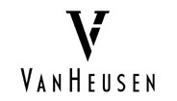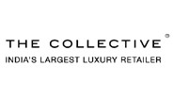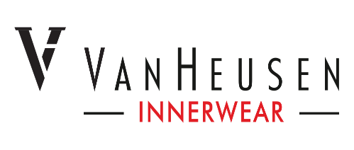

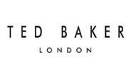



 

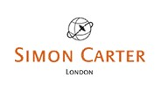 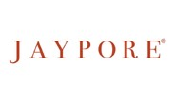

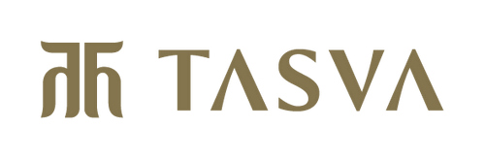

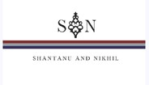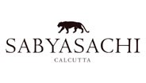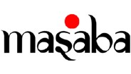

**LIST OF COMPETITORS**

[Future Lifestyle Fashions Ltd.](https://economictimes.indiatimes.com/future-lifestyle-fashions-ltd/stocks/companyid-47561.cms)  FUTLIF

|  |  |  |
| --- | --- | --- |
| [Heads UP Ventures Ltd.](https://economictimes.indiatimes.com/heads-up-ventures-ltd/stocks/companyid-52891.cms) | MANDRE | |
| [Kewal Kiran Clothing Ltd.](https://economictimes.indiatimes.com/kewal-kiran-clothing-ltd/stocks/companyid-15299.cms) | KEWKIR | |
| [Shoppers Stop Ltd.](https://economictimes.indiatimes.com/shoppers-stop-ltd/stocks/companyid-2646.cms) | PHOTO | |
| [Trent Ltd.](https://economictimes.indiatimes.com/trent-ltd/stocks/companyid-13456.cms) | TRENT | |
| [V2 Retail Ltd.](https://economictimes.indiatimes.com/v2-retail-ltd/stocks/companyid-15509.cms) | VISIT | |
|  | |  |

**NEWS ANALYSIS**

<https://economictimes.indiatimes.com/markets/stocks/recos/buy-aditya-birla-fashion-and-retail-target-price-rs-370-chandan-taparia/articleshow/94610411.cms>

# BRIEF OUTLININNG OF THE COMPANY

Aditya Birla Fashion and Retail cater to the contemporary customer who is aware of international trends and traditional styles. Its branded ethnic wear business includes brands such as 'Jaypore', ‘Tasva’ and ‘Marigold Lane’. ABFRL has strategic partnerships with designers 'Shantanu & Nikhil', 'Tarun Tahiliani', 'Sabyasachi' and ‘House of Masaba’, representing Indian decadence and modern grandeur. 'Van

Heusen's Innerwear, Athleisure and Active wear' is establishing itself in India. Its International business includes, 'The Collective' - India's largest international multi-brand retailer, select 'mono brands' and several 'premium global brands'[.](https://www.sabyasachi.com/)